**Python Mini Project Report**

**Name: Aarzav Jain**

**USN:22BTRSN001**

**Sem / Sec: 2nd**

# IoT based Indoor Hydroponics System

Hydroponics is the practise of growing plants without the use of soil and it incorporates the process of growing crops with the use of mineral fertiliser solutions in an aqueous solvent. As the name implies, hydroponics is a subset of hydroculture. This system nurtures quicker growth, much stronger yields, and supreme quality. Over the past years, farming in urban areas has gained a lot of recognition since it helps in maintaining a healthier and better lifestyle. In the conventional method of farming many difficulties are faced like weeding, pests, and climate, and not only that, soil-based agriculture introduces some soil-based crop diseases and it also requires large use of land [1]. Hence, the method of hydroponics is much more convenient nowadays as it decreases the burdensome physical labour of the farmers. The significance of hydroponics is to impart a way for one to grow their own food without the need for soil particularly for those people who live in urban settlements. Accurate pH level, air temperature, relative humidity, nutrient level of water, and correct irrigation of water are very important in hydroponics [2]. Thus, a management system that can monitor these factors is valuable and it will also ensure a higher success and efficiency rate of the yield. With the advancement of technology, we can use emerging technologies like the Internet of Things (IoT) to manage all the factors that are required in a hydroponics system.

In this context as a major key element, various sensors are used to measure the different environmental factors favourable for the growth of a plant such as the light intensity, temperature, hydrogen-ion activity in water- based solutions and thereby displaying the acidity or alkalinity reading expressed as pH.

**Abstract: This paper presents an IoT-based indoor hydroponics system designed to revolutionize modern agriculture through automation and real-time monitoring. Traditional agricultural practices face challenges like land limitations, unpredictable weather, and resource inefficiencies. Indoor hydroponics offers a promising solution to these issues by providing a controlled environment for plant growth. However, manual monitoring and management of hydroponics systems can be labor-intensive and prone to human errors.**

**Problem Statement:** **Traditional agricultural practices face significant challenges such as limited arable land, unpredictable weather conditions, and inefficient resource utilization. Inefficient irrigation methods and reliance on chemical fertilizers can lead to water wastage, soil degradation, and environmental pollution. Moreover, manual monitoring and management of hydroponic systems are labor-intensive and susceptible to human errors, hindering the potential for optimized crop growth.**

**The problem is to design an IoT-based hydroponic system that addresses these challenges and provides an automated, efficient, and sustainable solution for indoor plant cultivation. The system must integrate various sensors to monitor crucial environmental parameters such as water level, temperature, humidity, pH, and nutrient concentration. It should leverage IoT technology to enable real-time data transmission and remote control capabilities through a centralized platform.**

**Methodology:**

* Arduino Mega 2560- It is a microcontroller board that has been made based on the ATmega2560 microcontroller. As it can be seen, a 16 MHz crystal oscillator, 54 digital input/output pins, 16 analogue inputs, 4 UARTs (hardware serial ports), a USB connection, a power jack, an ICSP header, and a reset button are included and it is used as the main command and control module.
* 20x4 LCD - From the shown below, each of the four lines of a 20x4 LCD can display 20 characters per line with each character in a 5x7 pixel matrix. The two registers on this LCD are Command and Data. With the help of this display, data can be visualised.
* Analog pH sensor -It is a device that measures the pH of a solution and reflects the acidity or alkalinity of the solution. A pH metre has a pH probe with two electrodes, a sensor electrode and a reference electrode, which sends electrical impulses to the pH metre, which displays the solution's pH value.
* Analog TDS sensor- It is essentially an electrical charge (EC) metre as shown in that measures charge by inserting two electrodes evenly spaced into water. The excitation source is an AC signal, which can prevent polarisation and extend the probe's life while also increases the output signal's stability. TDS or EC levels have a huge impact on plant growth, development, and yields.
* DS18B20 thermostat - The DS18B20 digital thermometer measures temperatures from 9 to 12 bits in Celsius and has a non-volatile alarm function with user-programmable upper and lower trigger points. It communicates with a central CPU through a 1Wire bus, which requires only one data line (and ground) by definition.
* Dosing pump - A dosing pump is a positive displacement pump. It administers a chemical or another substance into a stream of water, gas, or steam. Dosing pumps are typically small, but they provide a very accurate flow rate for optimal control.
* Relay - A power relay module, which is an electrical switch, is controlled by an electromagnet which is set in motion by a separate low-power pulse sent by a microcontroller. The electromagnet pulls to open or close an electrical circuit when it detects an unwanted situation and sends orders to the circuit breaker to turn it ON/OFF. When the alarm is set to Enabled, the Relay is turned on, and the nutrient pump drains the nutrient solution from the hydroponics plant. When the alarm is turned off, the relay is turned off, and the nutrient pump stops working .

**Coding and Results**

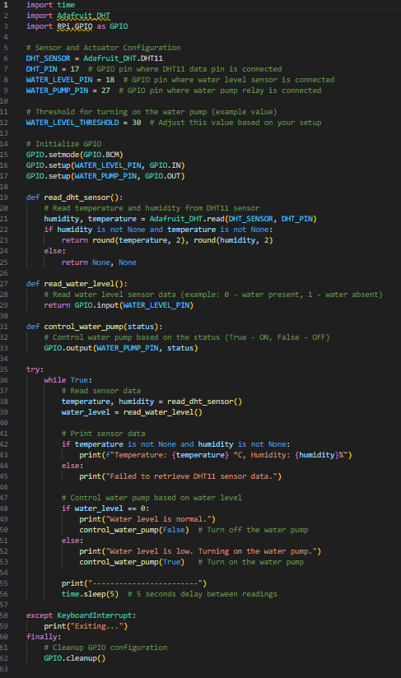

**OUTPUT:**

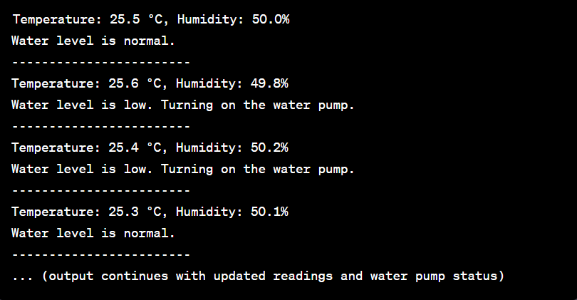

**Conclusion:**  In this paper, we have described the design and working principle of a hydroponics system that has been developed to enable advanced indoor agricultural techniques which can be accessed in urban areas. To manage and monitor certain environmental factors that are required in this hydroponics method, we have developed a system that can successfully gather data collected from the pH level sensor, water level sensor, air temperature and humidity sensor. The quality and production of the plants that are grown in our system are maximized by providing the best climatic conditions and nutrients depending upon the plant that is to be grown. The novelty in our work lies in the fact that it is aimed to practice the system on a small scale.